Creative sessions

Making Memories Group
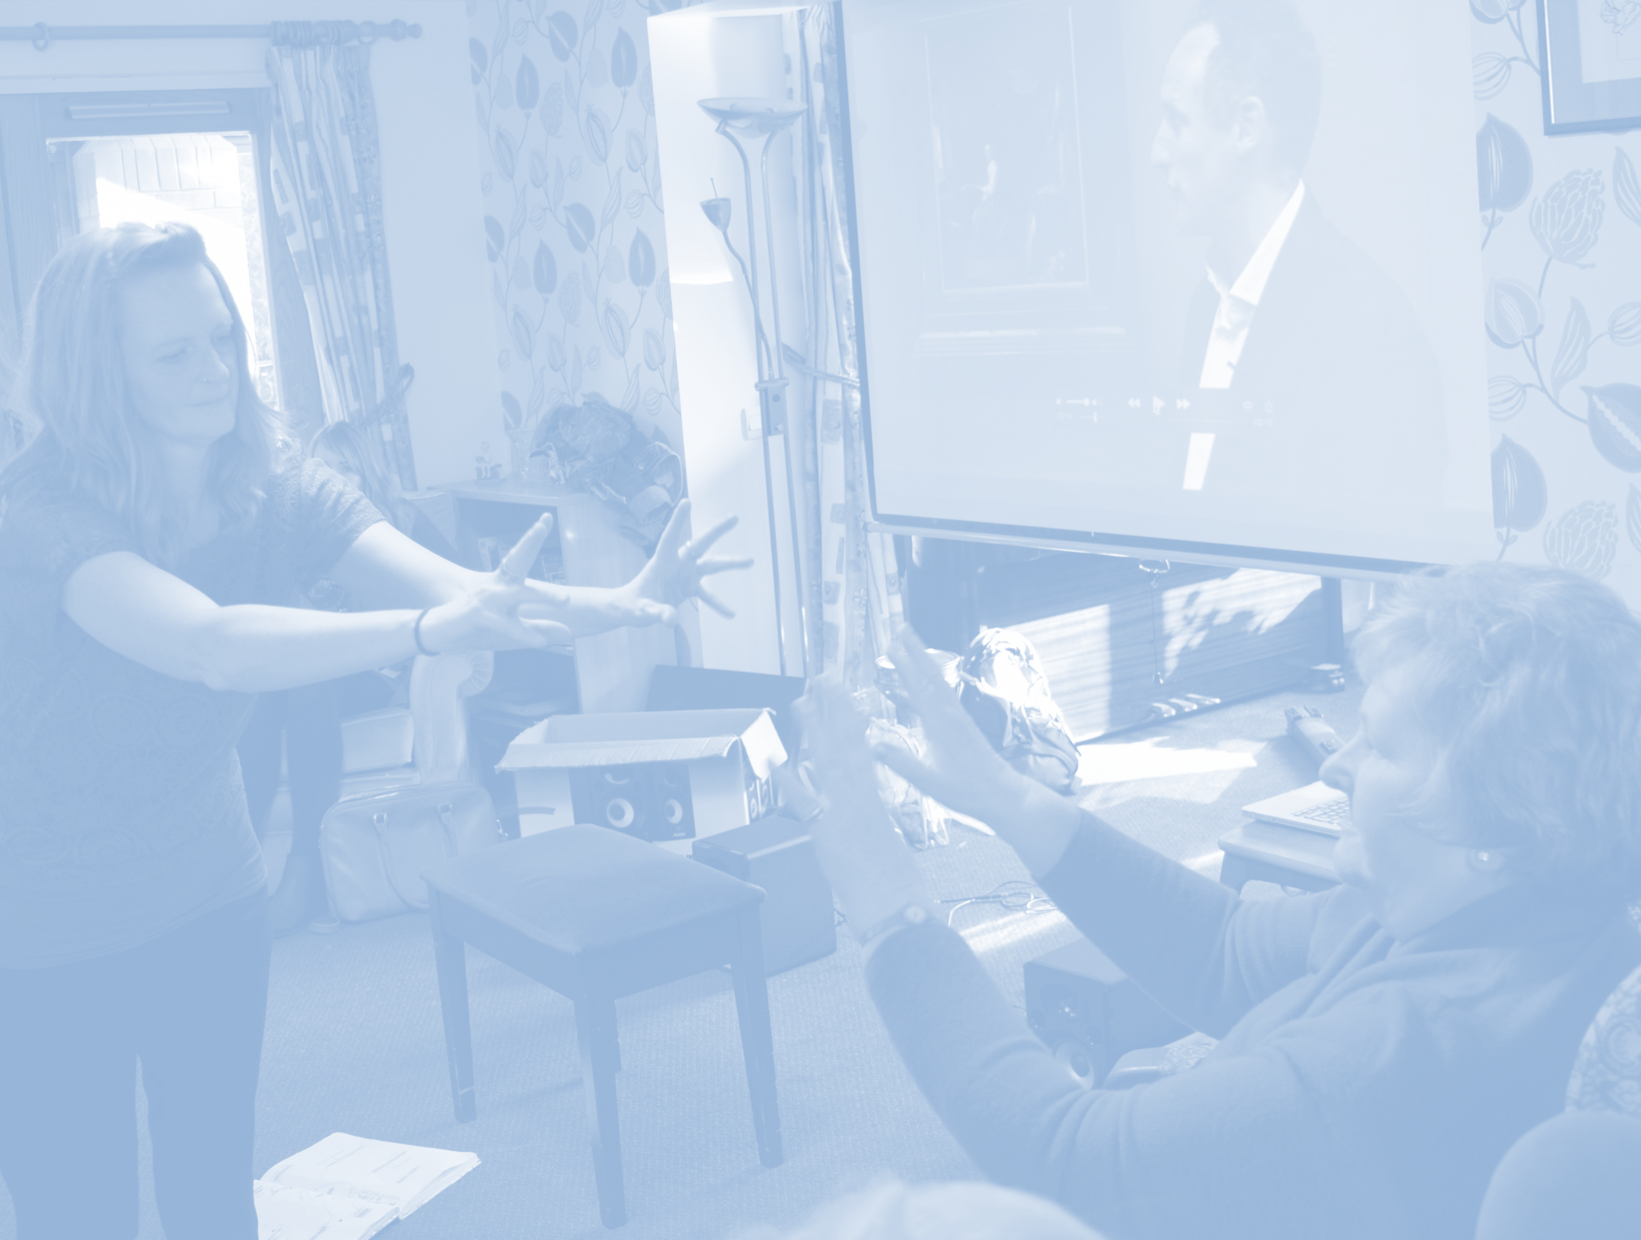

Sessions Inspired by
Mr Straw’s House (National Trust in Worksop)
Starts Thursdays
25th Jan —15th Mar
1.00—3.00 pm


